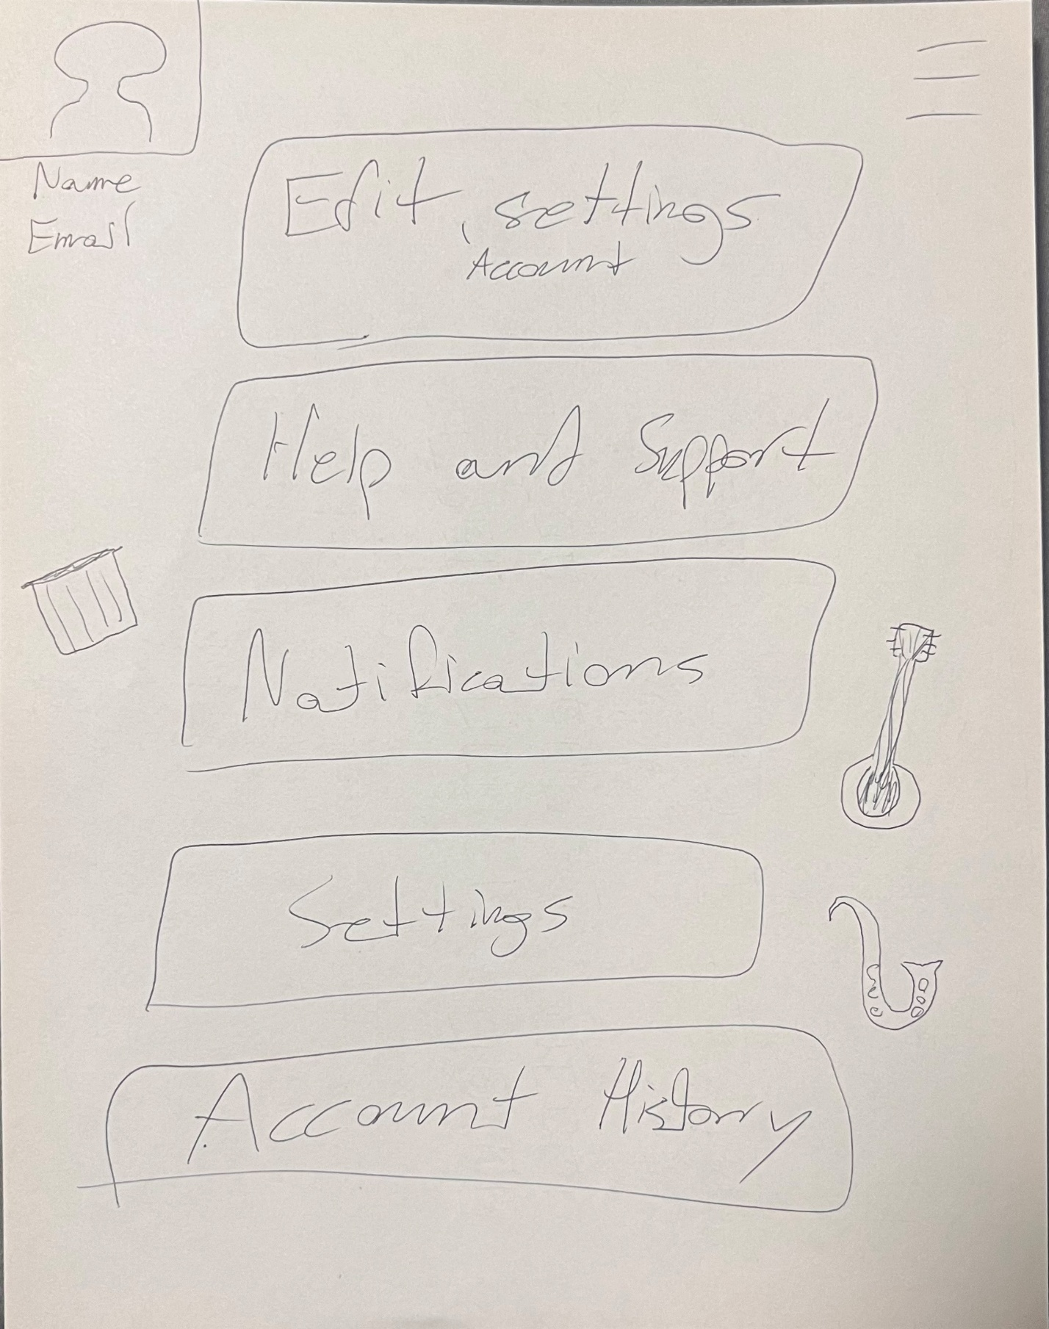

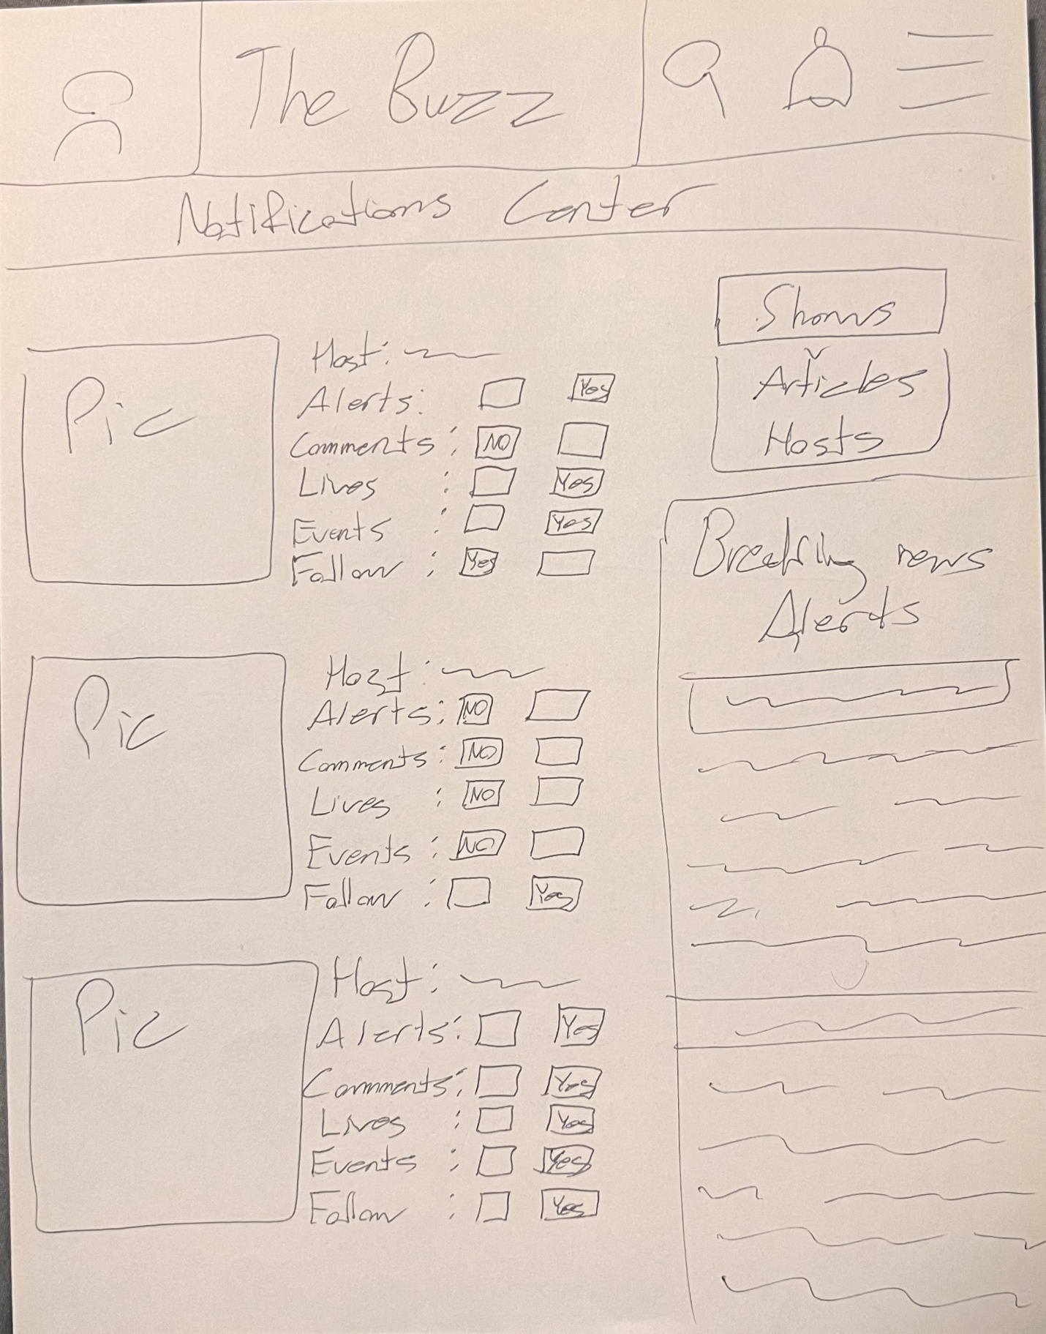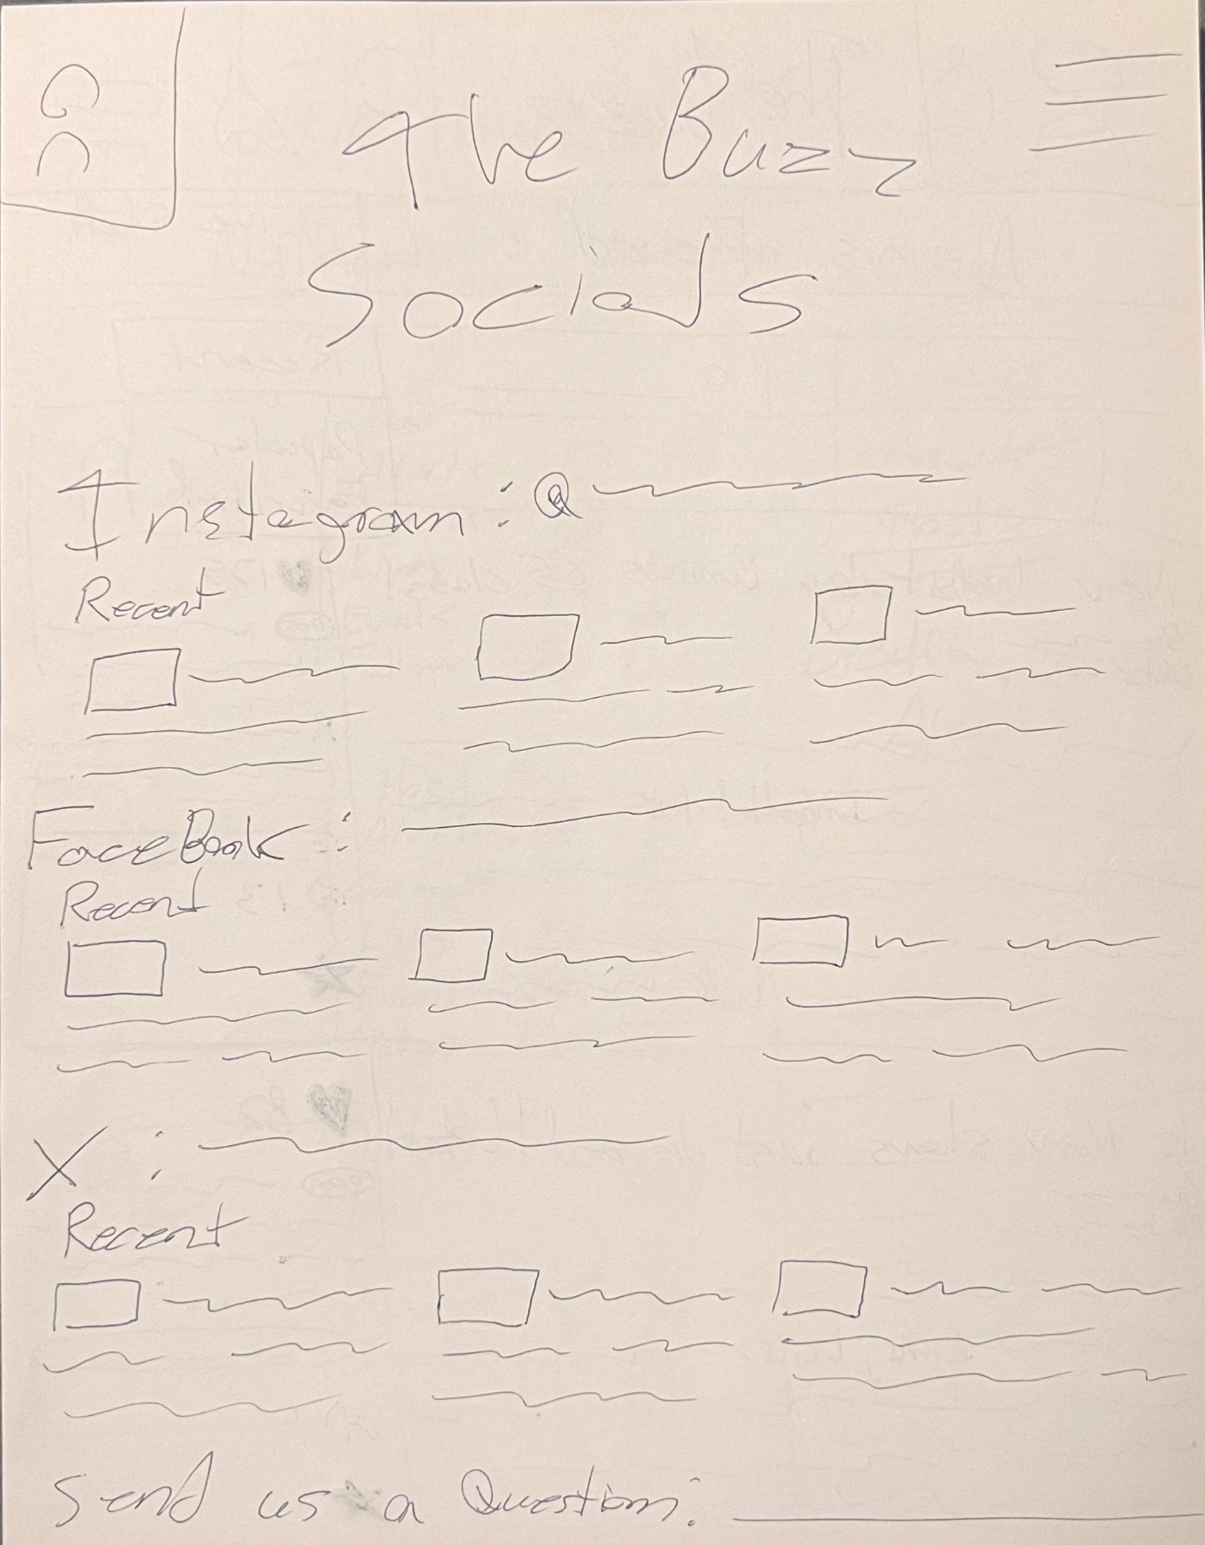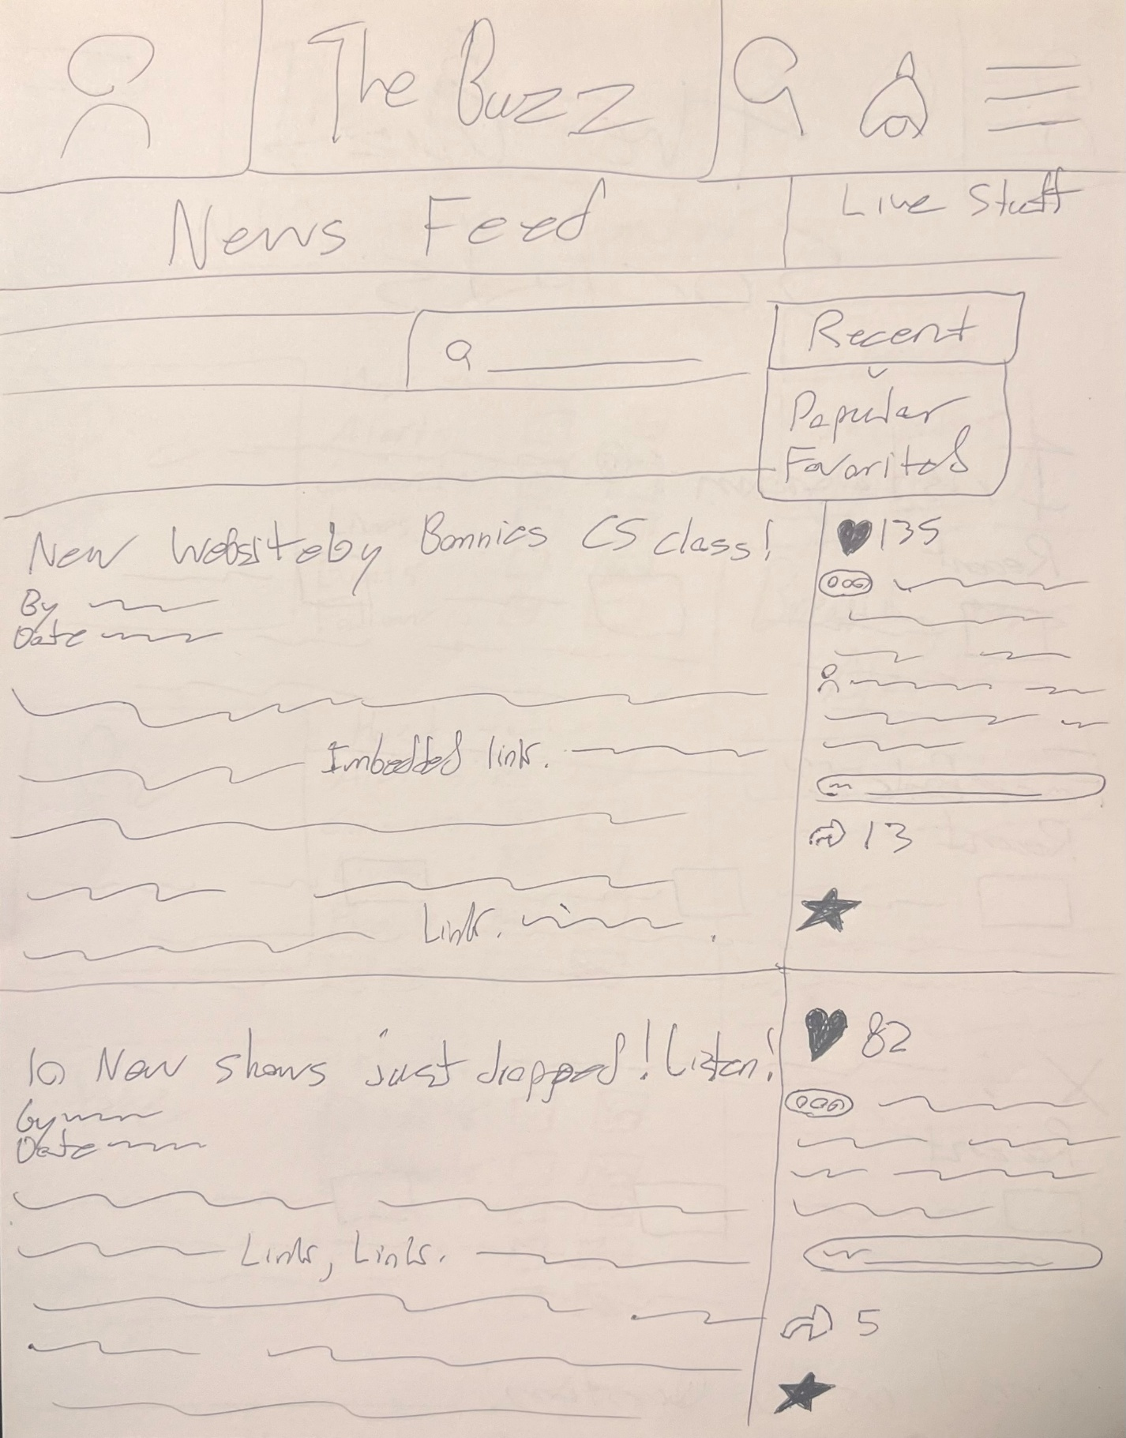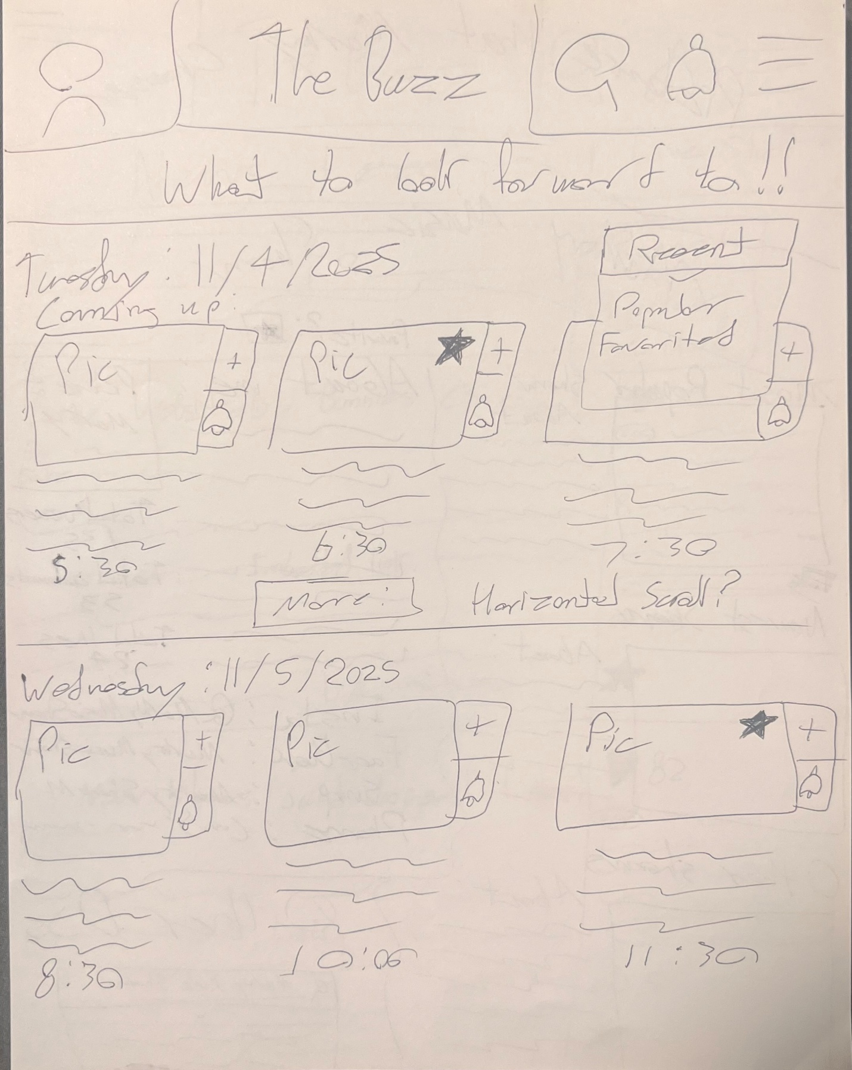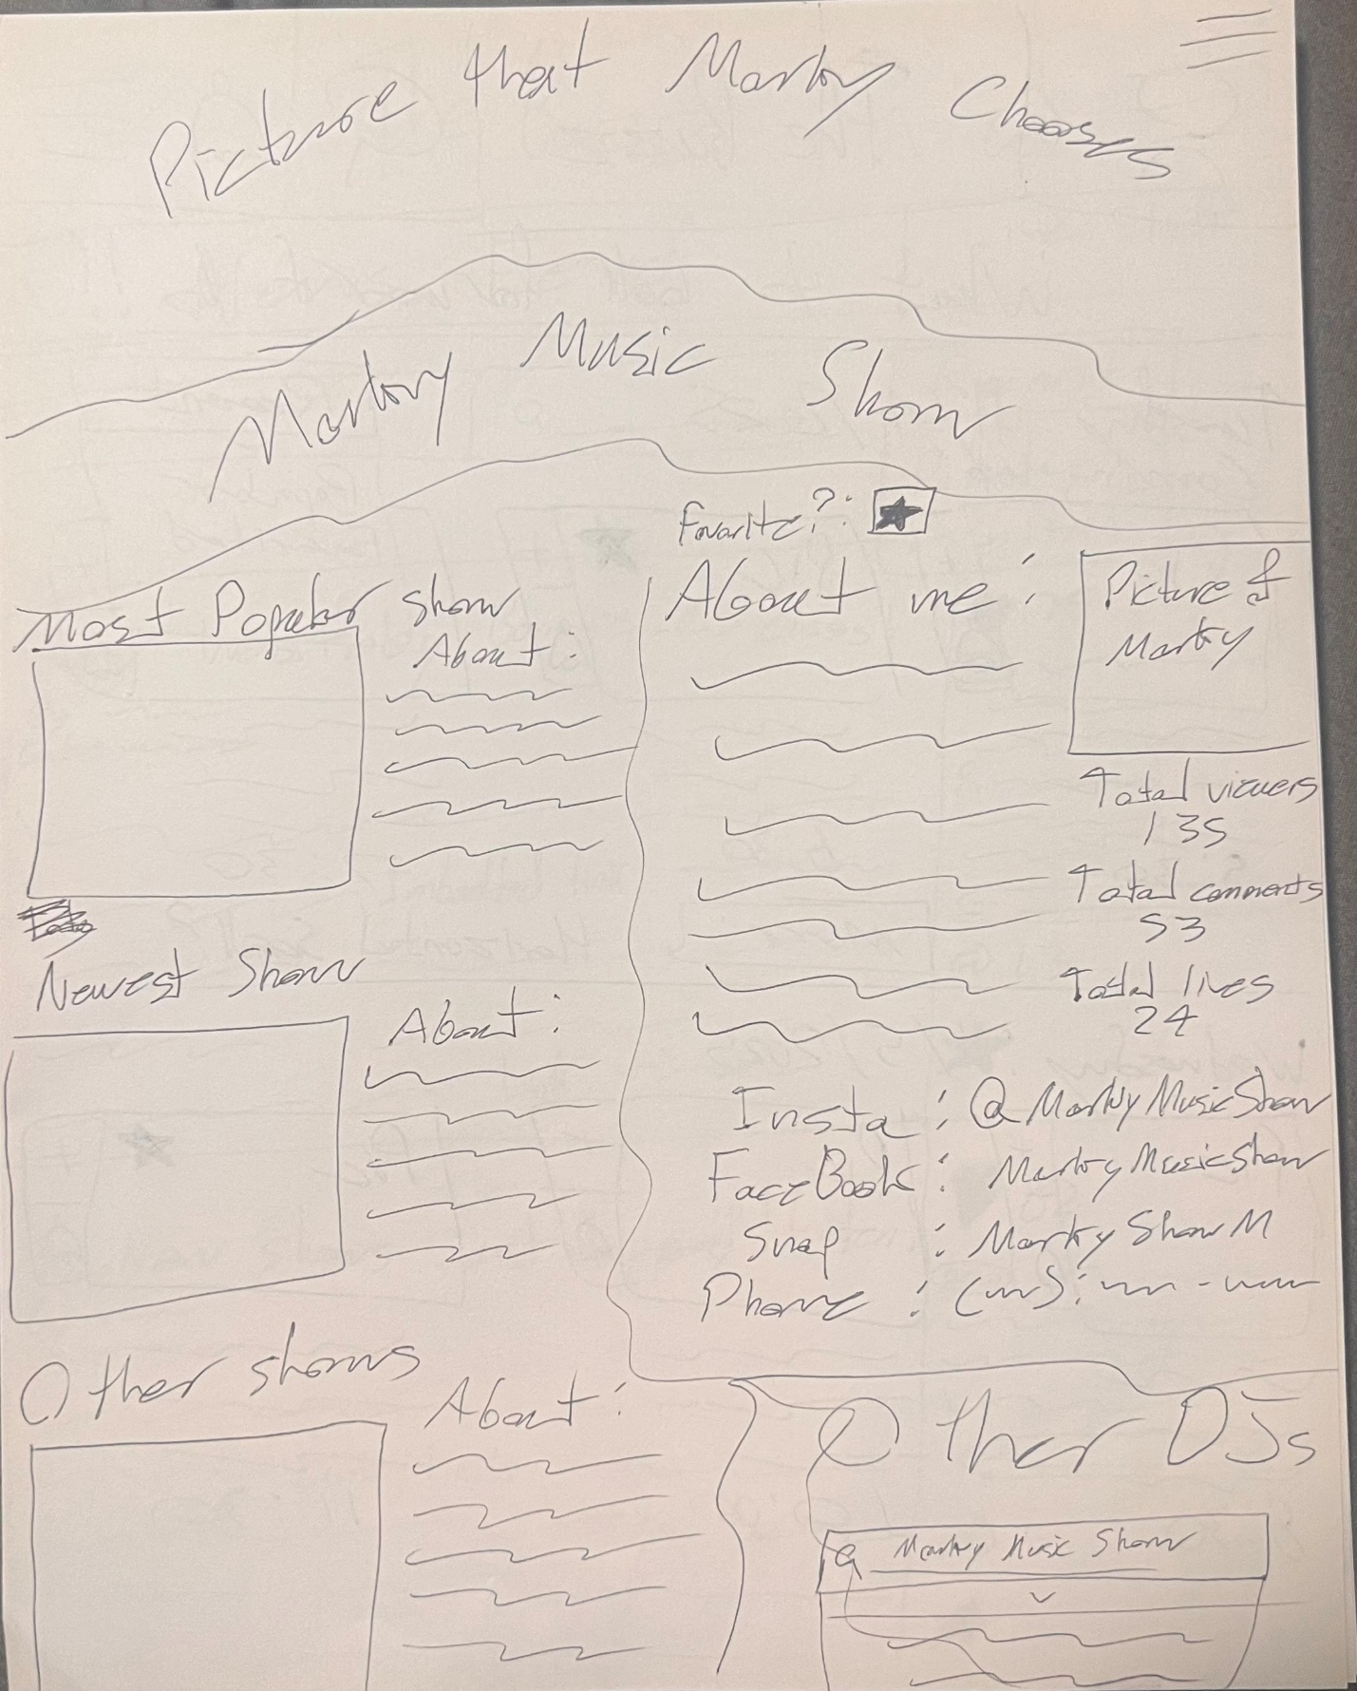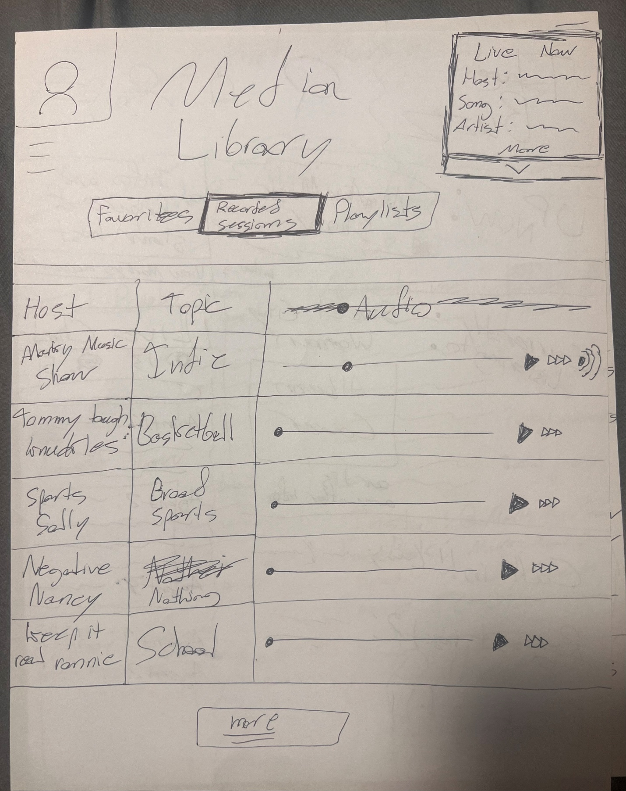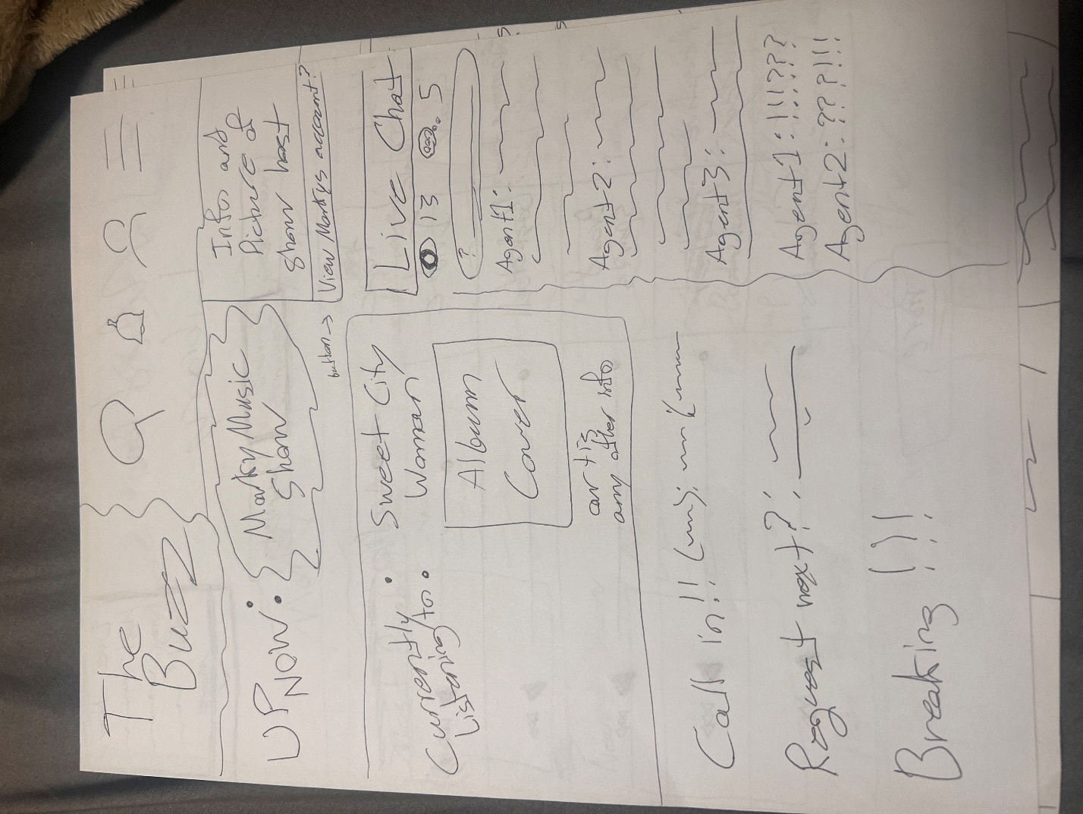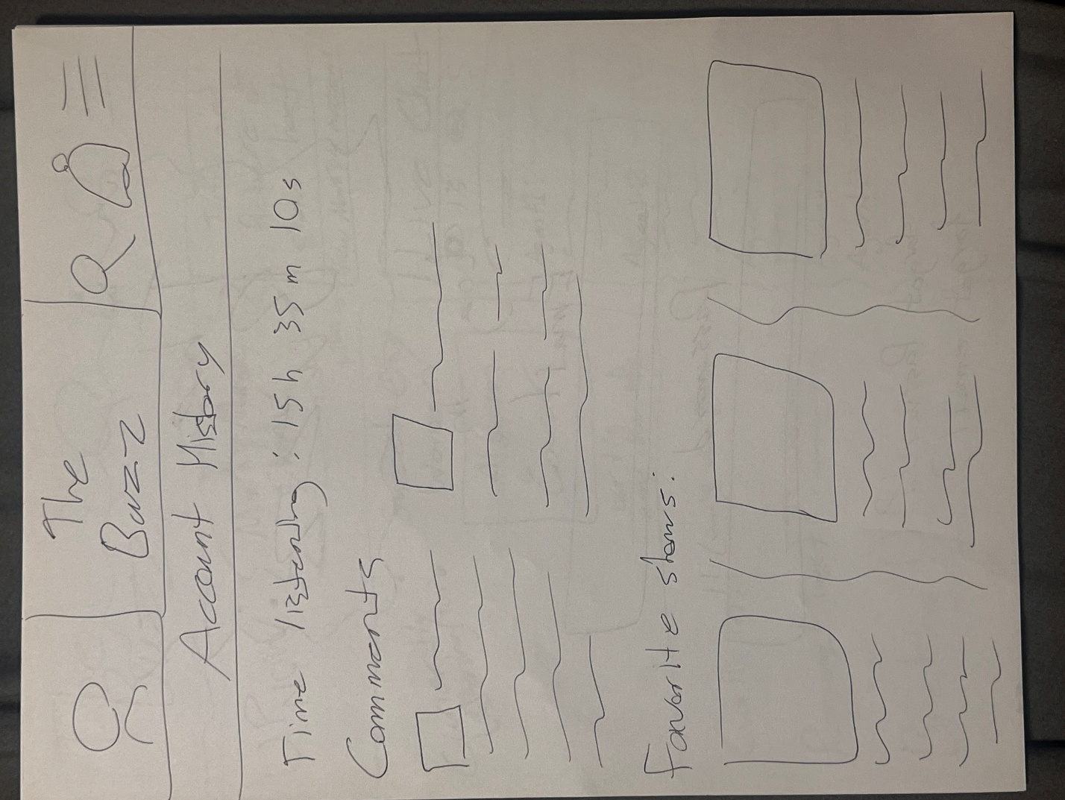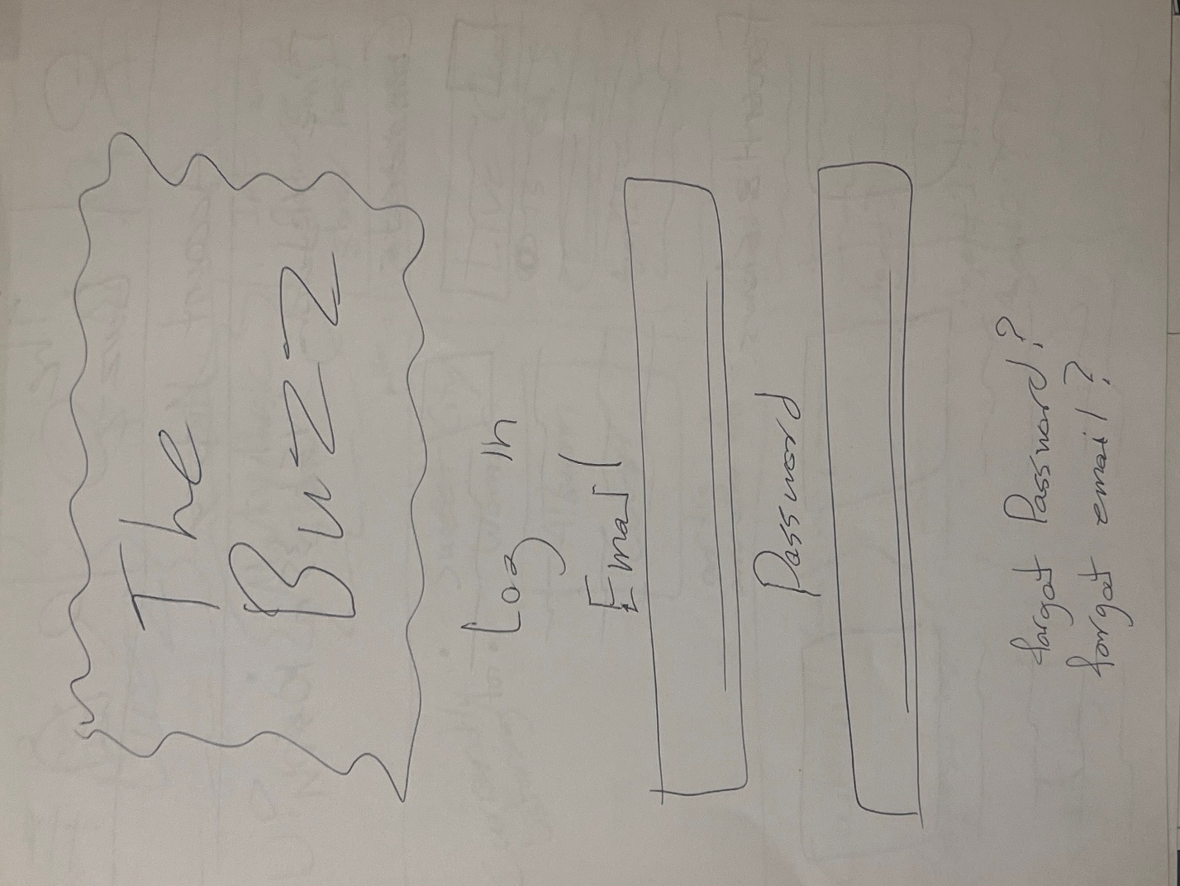

To begin this lab, I first thought about all the Buzz teams need for their application. They had so many requests that it was obvious we had to include multiple parts on multiple pages. Due to this I decided to prototype 10 different pages that mostly incapsulated their vision.

1. Settings navigation page

It was important to me to have a concrete way to navigate through adjustable settings, help menu and more. It would give people more freedom in how they view the app.

1. Notifications center

My original plan for this was to allow people to adjust each DJs setting for when they come on. It also includes the breaking news module.

1. The Buzz Socials

A page for management and the buzz team to link their socials This will allow people to reach them for questions, or to find out about future updates.

1. News feed

Page for all news articles. It has a like, comment, and favorite function so that people can interact with it.

1. What to look forward to section

An update section that lists upcoming events and shows. It separates it by day of week and has a dropdown menu to sort.

1. DJ page (Marky Music Show)

Lists their most popular show, their newest show and other shows (If they run multiple shows). Has an about me section with a place to link their socials. Also includes an optional photo and a tracking of their total viewers, comments and lives. At the bottom right is a place to look for other DJs.

1. Media Library

It has 3 different options at the top, favorites, recorded sessions and playlists. The shown section (recorded sessions) has a hostname, topic and audio. The other sections would have similar UI.

1. Main page

It has an UP NOW section to give details about the current live show which also includes a picture. It has a “currently listening to” section that displays details about the artist and song, also with an album cover. It has a call-in section, request section and a breaking news section. The last function is the live chat which allows people to communicate with each other while listening to music.

1. Account history

Compiles all activity on the site. This includes time on the site, comments, liked sections and more.

1. The buzz login page

A simple login page.

These were the 10 prototype pages that I ended up making before the design of the project.

When it came time to make the project, Me and Calebs ideas clashed a bit, so we decided to just start making the different parts of the website and update it as we went. I settled on making the favorites section and the settings section and some of the functionality. Overall, it worked out well since we had the same vision somewhat.

Reflection:

Overall, this was a lot to handle. They requested a lot of functionality which in turn came to 30 pages of design. It was a very fun project but there’s still a lot to improve on.

Some of the tradeoffs we faced were how limiting Figma is. We had many ideas and so did the Buzz team, but some of what they need is hard to bring to life, at least at our skill level. With time this could become a fleshed-out site and I’m excited to work on it more.

<https://www.figma.com/design/oaGVQF69uALAVjFFs09UPA/WSBU-88.3-The-Buzz-Design?node-id=0-1&p=f&t=RBA4gSEkHOYeak2N-0>